**SMTP**

**Step-01**

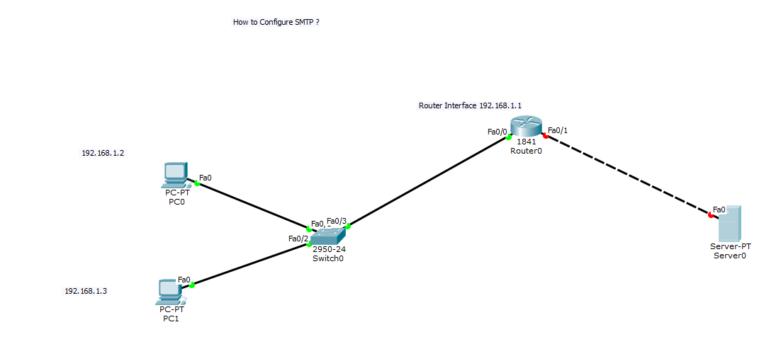

**Step-02 Test PC to router**

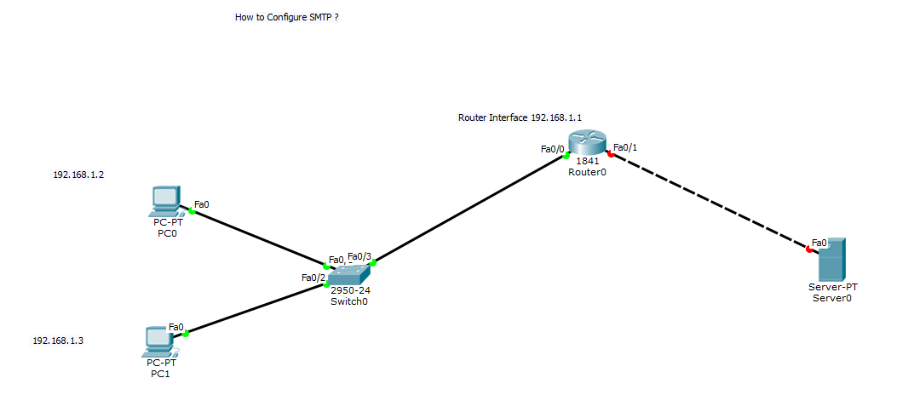

**Step-03 Domain Name**

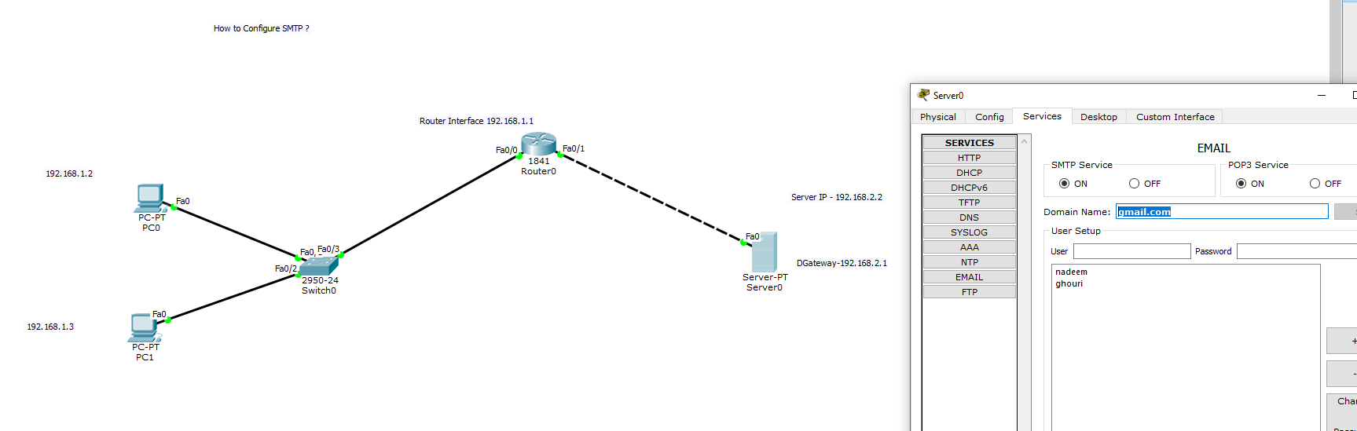

**Step-04 Router to server**

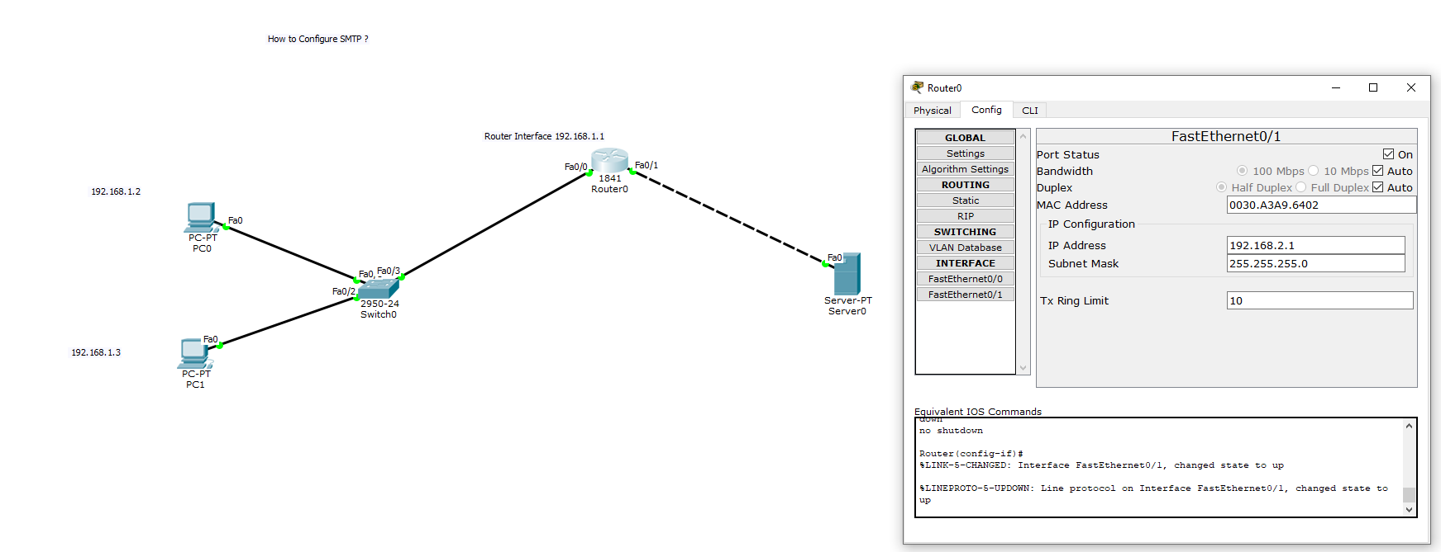

**Step-05 Server IPs**

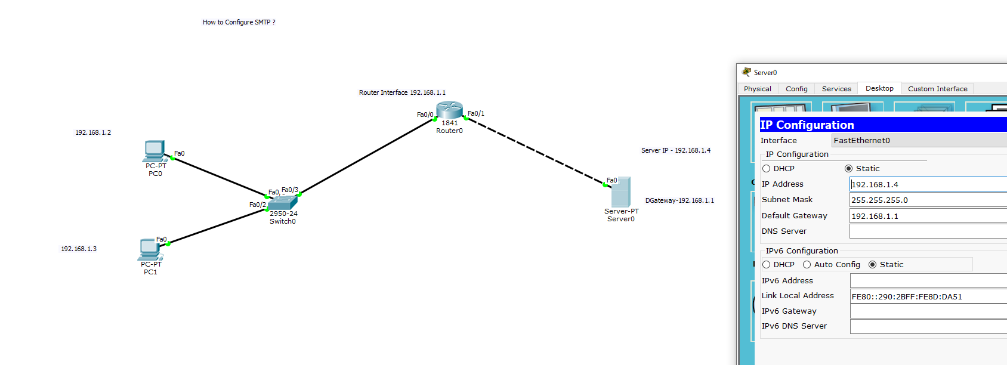

**Step-06 Configure Mail User-1 /PC0**

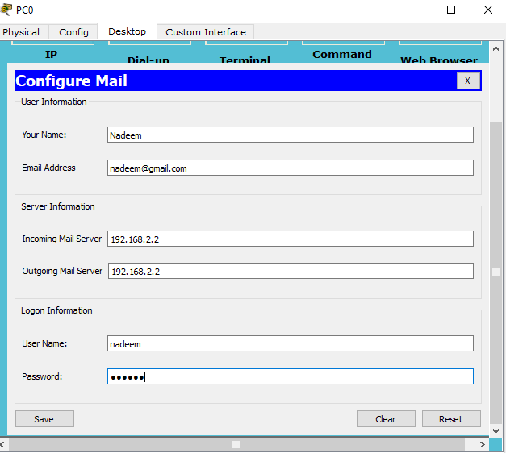

**Step-07 Configure Mail User-2 /PC1**

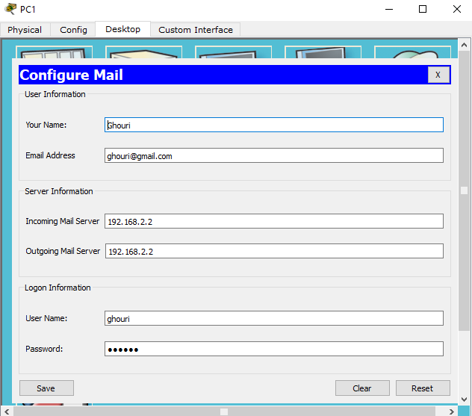

**Step-08 Compose email and send email**



**Step-09 Sent Email PC0 to PC1 and check on PC-1**

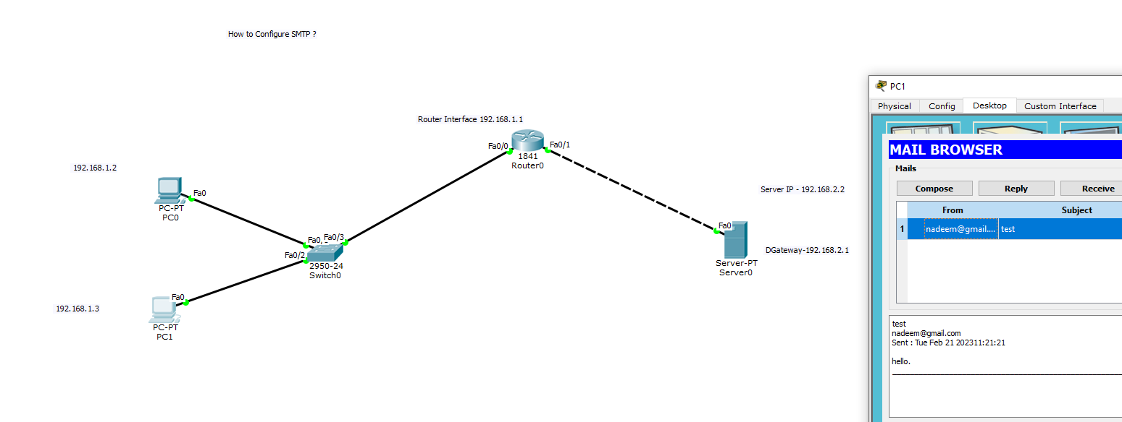

**Step-10 Reply Email PC1 to PC0 and check on PC-0**

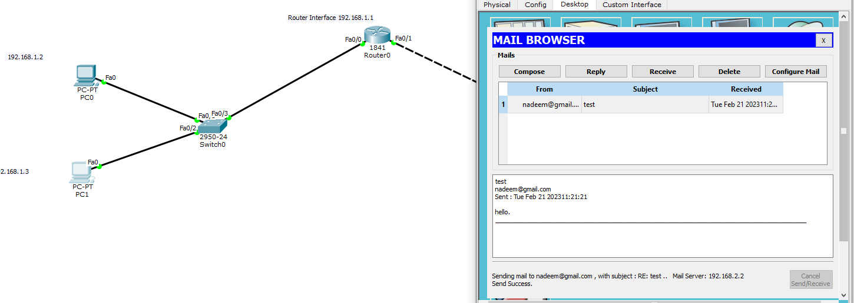

**Step-11 Check Reply**

